Michael Weaver

CST – 221

John Zupan

2/25/18

GitHub Link: <https://github.com/battousairurik/CST-221>

**Table 1: File Systems**

|  |  |
| --- | --- |
| **Directory** | **Purpose** |
| / | Signifies the root directory, stores all system software allowing the system to boot. |
| /bin | Directory which stores execution details for all binary, terminal commands. |
| /dev | Directory where all hardware devices are stored for system use. Without this directory the system would likely cease function. |
| /etc | Directory which contains global system configuration files which affect all users. |
| /lib | Directory which contains the system libraries and kernel modules. |
| /boot | Directory containing the static boot loader files, including the kernel and RAM disk image loader. |
| /home | Directory containing user specific home data. This is where all directories and files for that user are stored. Each user gets their own home directory. |
| /mnt | Directory for temporarily mounting a file system directory, like a network file system. |
| /proc | Proc is the virtual file system which the kernel uses to transfer data to processes. |
| /tmp | Directory where applications can store temporary files. Internet cookies are an example of this. |
| /usr | Directory which defines all user specific utilities and applications, allowing the user to interact with the system. |
| /var | Directory containing variable data such as logs, databases, websites, or emails. |
| /sbin | Directory which contains all of the superuser administrative commands. |
| /kernel | Directory not typically installed. It contains the full kernel which can be customized by the programmer as needed. |

**Table 2: Root Directory**

|  |  |
| --- | --- |
| **Directory** | **Purpose** |
| /bin | *Reference Table 1* |
| /boot | *Reference Table 1* |
| /cdrom | Directory which contains all of the processes to handle CD’s and DVD’s. CD/DVD drivers are stored here. |
| /dev | *Reference Table 1* |
| /etc | *Reference Table 1* |
| /home | *Reference Table 1* |
| /initrd.img | Automatic package update image which becomes obsolete after each new update. |
| /lib | *Reference Table 1* |
| /lib64 | Similar to the /lib directory but specifically for 64-bit data. |
| /lost+found | Directory used to store corrupt portions of files that are abandoned while saving or shutting down. |
| /media | Directory similar to /mnt but is specifically used for automatic system mounting of programs and applications. |
| /mnt | *Reference Table 1* |
| /opt | Directory used for the instillation of add on application software packages. |
| /proc | *Reference Table 1* |
| /root | *Reference Table 1* |
| /run | Directory to store transient state files, or files which contain run time data which is not required for reboots. |
| /sbin | *Reference Table 1* |
| /snap | Directory used to store Ubuntu snap applications. Snaps are a newer Ubuntu method to package middleware which is highly customizable. |
| /srv | Directory to store system specific data on services offered by the system. |
| /sys | Directory which acts as an interface for the kernel, though is a bit outdated. It provides information and configuration settings of the kernel. |
| /tmp | *Reference Table 1* |
| /usr | *Reference Table 1* |
| /var | *Reference Table 1* |
| /vmlinuz | This is either a link to or the real kernel bootable. It is considered a basic part of the Ubuntu OS. |

**Flowchart for simulated C Compiler**

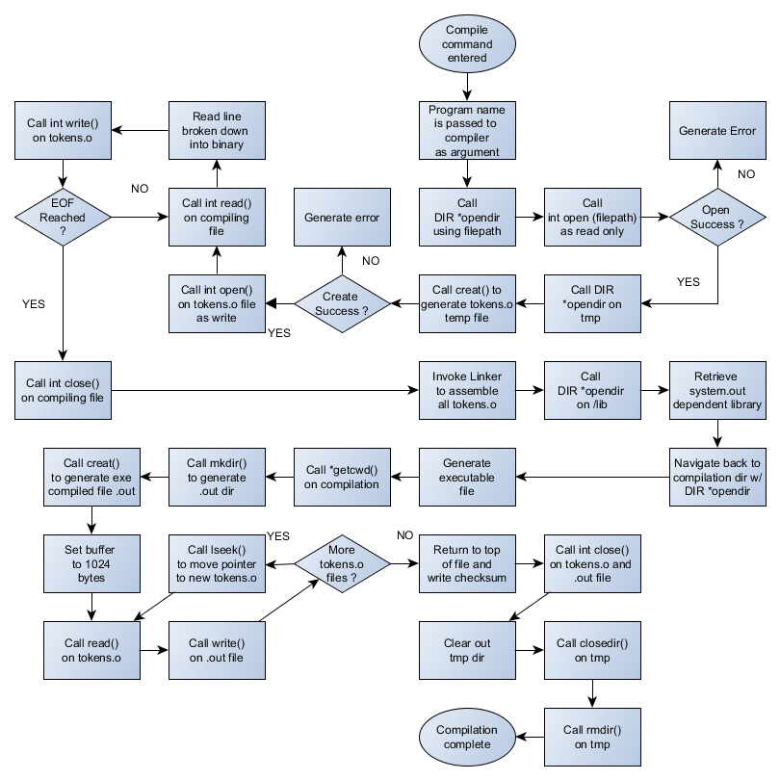

**References**

Ubuntu Documentation. (2018). *LinuxFilesystemTreeOverview*. Retrieved from <https://help.ubuntu.com/community/LinuxFilesystemTreeOverview>

Help.Ubuntu.com. (2018). *C.2. The Directory Tree*. Retrieved from <https://help.ubuntu.com/lts/installation-guide/s390x/apcs02.html>

AskUbuntu.com. (2016). *What's the “/sys” directory for*? Retrieved from <https://askubuntu.com/questions/720471/whats-the-sys-directory-for>

Okoi, Martins D. (2017). *What Are Snaps? And How Are They Important*? Retrieved from <https://www.fossmint.com/what-are-ubuntu-snaps-and-how-are-they-important/>

Debian.org. (2011). *Release Goals Run Directory*. Retrieved from <https://wiki.debian.org/ReleaseGoals/RunDirectory#A.2Frun>

Pathname.com. (2004). *Filesystem Hierarchy Standard*. Retrieved from <http://www.pathname.com/fhs/pub/fhs-2.3.html#FTN.AEN1192>

Jilliagre. (2012). *What is the difference between /opt and /usr/local*? Retrieved from <https://unix.stackexchange.com/questions/11544/what-is-the-difference-between-opt-and-usr-local>

Nux. (2015). *what is Vmlinuz file on live ubuntu*? Retrieved from <https://askubuntu.com/questions/452070/what-is-vmlinuz-file-on-live-ubuntu>

GeeksforGeeks. (2018). *Compiling a C program: - Behind the Scenes*. Retrieved from <https://www.geeksforgeeks.org/compiling-a-c-program-behind-the-scenes/>